1
ETU-LINKNK

SFP
Optical Communication System
ESCxx24-3LCD80
2.67Gbps CWDM SFP Optical Transceiver,
80KM Reach
- Data-rate of 2.67Gbps operation
- 18 CWDM DFB wavelengths laser and APD photodetector for
80KM transmission
- Compliant with SFP MSA and SFF-8472 with duplex LC receptacle
- Digital Diagnostic Monitoring:
Internal Calibration or External Calibration
- Compatible with RoHS
- +3.3V single power supply
Operating case temperature: Standard: 0 to +70°C

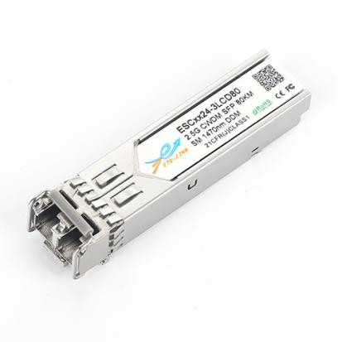

Applications

- Switch to Switch Interface
- Gigabit Ethernet
- Switched Backplane Applications
- Router/Server Interface
- Other Optical Links

Description
ETU-Link’s ESCxx24-3LCD80 Small Form Factor Pluggable (SFP) transceivers are compatible with the Small Form Factor Pluggable Multi-Sourcing Agreement (MSA). The transceiver consists of five sections: the LD driver, the limiting amplifier, the digital diagnostic monitor, the 1XX0nm DFB laser and the APD .The module data linkup to 80KM in 9/125um single mode fiber.

The optical output can be disabled by a TTL logic high-level input of Tx Disable, and the system also can disable the module via I2C. Tx Fault is provided to indicate that degradation of the laser. Loss of signal (LOS) output is provided to indicate the loss of an input optical signal of receiver or the link status with partner. The system canalso get the LOS (or Link)/Disable/Fault information via I2C register access.
Module Block Diagram

2
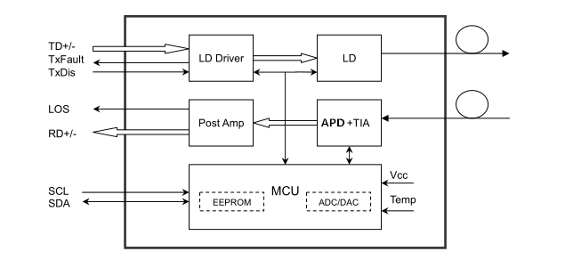
Product Selection

ESCXX24-3LCD80
Wavelength | xx | Clasp Color Code | Wavelength | xx | Clasp Color Code
1470 nm | 47 | Gray | 1550 nm | 55 | Yellow
1490 nm | 49 | Purple | 1570 nm | 57 | Orange
1510 nm | 51 | Blue | 1590 nm | 59 | Red
1530 nm | 53 | Green | 1610 nm | 61 | Brown
Recommended Operating Conditions

Parameter | Symbol | Min. | Typ. | Max. | Unit | Note
Case Operating Temperature | Tcase | 0 |  | 70 | ºC
Power Supply Voltage | VCC | 3.13 | 3.3 | 3.47 | V
Power Supply Current | ICC |  |  | 300 | mA
Power Supply Noise Rejection |  |  |  | 100 | mVp-p | 100Hz to 1MHz
Data Rate |  |  | 2670 |  | Mbps | TX Rate/RX Rate
Transmission Distance |  |  |  | 80 | KM
Coupled Fiber | Single mode fiber |  |  |  |  | 9/125um SMF
3

Specification of Transmitter

Parameter | Symbol | Min. | Typ. | Max. | Unit | Note
Average Output Power | POUT | 1 |  | 5 | dBm | Note (1)
Extinction Ratio | ER | 9 |  |  | dB
Center Wavelength | λC | (1XX0)-∆λ | 1XX0 | (1XX0)+∆λ | nm | DFB Laser  Note (2)
Side Mode Suppression Ratio | SMSR | 30 |  |  | dB
Spectrum Bandwidth(-20dB) | σ |  |  | 1 | nm
Transmitter OFF Output Power | POff |  |  | -45 | dBm
Differential Line Input Impedance | RIN | 90 | 100 | 110 | Ohm
Output Eye Mask | Compliant with G.957 (class 1 laser safety) |  |  |  |  | Note (3)
Notes
- Measure at 2^23-1 NRZ PRBS pattern
- “XX” is: 47,49,51,53,55,57,59 and 61; “∆λ” is 7.5
- Transmitter eye mask definition

x₃-x₂ | 0.2
y₁ | 0.25
y₂ | 0.75
y₃ | 0.25
y₄ | 0.25
Specification of Receiver

Parameter | Symbol | Min. | Typ. | Max. | Unit | Note
Input Optical Wavelength | λIN | 1270 |  | 1610 | nm | APD
Receiver Sensitivity | PIN |  |  | -28 | dBm | Note (1)
Input Saturation Power (Overload) | PSAT | -9 |  |  | dBm
Los Of Signal Assert | PA | -40 |  |  | dBm
Los Of Signal De-assert | PD |  |  | -30 | dBm | Note (2)
LOS Hysteresis | PA-PD | 0.5 | 2 | 6 | dB
Notes
- The optical power is launched into SMF.
- PECL input, internally AC-coupled and terminated.
- Measured with a PRBS 223-1 test pattern @2488Mbps, BER ≤1×10-12
4
- AC-coupled internally.
Electrical Interface Characteristics
Parameter | Symbol | Min. | Typ. | Max. | Unit | Note
Transmitter
Total Supply Current | ICC |  |  | A | mA | Note (1)
Transmitter Disable Input-High | VDISH | 2 |  | Vcc+0.3 | V
Transmitter Disable Input-Low | VDISL | 0 |  | 0.8 | V
Transmitter Fault Input-High | VTxFH | 2 |  | Vcc+0.3 | V
Transmitter Fault Input-Low | VTxFL | 0 |  | 0.8 | V
Receiver
Total Supply Current | ICC |  |  | B | mA | Note (1)
LOSS Output Voltage-High | VLOSH | 2 |  | Vcc+0.3 | V | LVTTL
LOSS Output Voltage-Low | VLOSL | 0 |  | 0.8 | V
Notes
- A (TX) + B (RX) = 300mA (Not include termination circuit)
Pin Definitions

Pin | Symbol | Name/Description | NOTE
1 | VEET | Transmitter Ground (Common with Receiver Ground) | 1
2 | TFAULT | Transmitter Fault.
3 | TDIS | Transmitter Disable. Laser output disabled on high or open. | 2
4 | MOD_DEF(2) | Module Definition 2. Data line for Serial ID. | 3
5 | MOD_DEF(1) | Module Definition 1. Clock line for Serial ID. | 3
6 | MOD_DEF(0) | Module Definition 0. Grounded within the module. | 3
7 | Rate Select | No connection required | 4
8 | LOS | Loss of Signal indication. Logic 0 indicates normal operation. | 5
9 | VEER | Receiver Ground (Common with Transmitter Ground) | 1
10 | VEER | Receiver Ground (Common with Transmitter Ground) | 1
11 | VEER | Receiver Ground (Common with Transmitter Ground) | 1
12 | RD- | Receiver Inverted DATA out. AC Coupled
13 | RD+ | Receiver Non-inverted DATA out. AC Coupled
14 | VEER | Receiver Ground (Common with Transmitter Ground) | 1
15 | VCCR | Receiver Power Supply
16 | VCCT | Transmitter Power Supply
17 | VEET | Transmitter Ground (Common with Receiver Ground) | 1
18 | TD+ | Transmitter Non-Inverted DATA in. AC Coupled.
19 | TD- | Transmitter Inverted DATA in. AC Coupled.
20 | VEET | Transmitter Ground (Common with Receiver Ground) | 1
Notes
5
- Circuit ground is internally isolated from chassis ground.
- Laser output disabled on TDIS>2.0V or open, enabled on TDIS<0.8V.
- Should be pulled up with 4.7k - 10kohms on host board to a voltage between 2.0V and 3.6V.MOD_DEF (0) pulls line low to indicate module is plugged in.
- This is an optional input used to control the receiver bandwidth for compatibility with multiple data rates (most likely Fiber Channel 1x and 2x Rates).If implemented, the input will be internally pulled down with > 30kΩ resistor. The input states are:
  - Low (0 – 0.8V): Reduced Bandwidth
  - (>0.8, < 2.0V): Undefined
  - High (2.0 – 3.465V): Full Bandwidth
  - Open: Reduced Bandwidth
- LOS is open collector output should be pulled up with 4.7k - 10kohms on host board to a voltage between 2.0V and 3.6V. Logic 0 indicates normal operation; logic 1 indicates loss of signal.
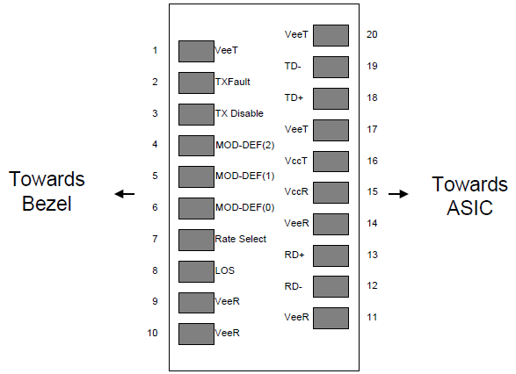
Figure2. Pin out of Connector Block on Host Board
Absolute Maximum Ratings

6
Parameter | Symbol | Min. | Typ. | Max. | Unit | Note
Storage Temperature | Ts | -40 |  | 85 | ºC
Relative Humidity | RH | 5 |  | 95 | %
Power Supply Voltage | VCC | -0.5 |  | 4 | V
Signal Input Voltage |  | -0.3 |  | Vcc+0.3 | V
Receiver Damage Threshold |  | +6 |  |  | dBm

Digital Diagnostic Functions

ETU-LINK ESCXX24-3LCD80 transceivers support the 2-wire serial communication protocol as defined in the SFP MSA. It is very closely related to the E2PROM defined in the GBIC standard, with the same electrical specifications.
The standard SFP serial ID provides access to identification information that describes the transceiver’s capabilities, standard interfaces, manufacturer, and other information.

Additionally, ETU-LINK SFP transceivers provide a unique enhanced digital diagnostic monitoring interface, which allows real-time access to device operating parameters such as transceiver temperature, laser bias current, transmitted optical power, and received optical power and transceiver supply voltage. It also defines a sophisticated system of alarm and warning flags, which alerts end-users when particular operating parameters are outside of a factory set normal range.

The SFP MSA defines a 256-byte memory map in E2PROM that is accessible over a 2-wire serial interface at the 8 bit address 1010000X (A0h). The digital diagnostic monitoring interface makes use of the 8 bit address 1010001X (A2h), so the originally defined serial ID memory map remains unchanged. The interface is identical to, and is thus fully backward compatible with both the GBIC Specification and the SFP Multi Source Agreement.

The operating and diagnostics information is monitored and reported by a Digital Diagnostics Transceiver Controller (DDTC) inside the transceiver, which is accessed through a 2-wire serial interface. When the serial protocol is activated, the serial clock signal (SCL, Mod Def 1) is generated by the host. The positive edge clocks data into the SFP transceiver into those segments of the E2PROM that are not write-protected. The negative edge clocks data from the SFP transceiver. The serial data signal (SDA, Mod Def 2) is bi-directional for serial data transfer. The host uses SDA in conjunction with SCL to mark the start and end of serial protocol activation. The memories are organized as a series of 8-bit data words that can be addressed individually or sequentially.

Digital diagnostics for the ESCXX24-3LCD80 are internally calibrated by default

7
Mechanical Specifications

Regulatory Compliance

Feature | Reference | Performance
Electrostatic discharge（ESD） | IEC/EN 61000-4-2 | Compatible with standards
Electromagnetic Interference (EMI) | FCC Part 15 Class B EN 55022 Class B (CISPR 22A) | Compatible with standards
Laser Eye Safety | FDA 21CFR 1040.10, 1040.11 IEC/EN 60825-1, 2 | Class 1 laser product
Component Recognition | IEC/EN 60950, UL | Compatible with standards
ROHS | 2002/95/EC | Compatible with standards
EMC | EN61000-3 | Compatible with standards

8
Compatibility Test

In order to ensure the product compatibility, our products will be tested on the switch before shipment. Our modules can compatible with many mainstream brand switches, such as Cisco, Juniper, Extreme, Brocade, IBM, H3C, HP, Huawei, D-Link, Mikrotik, ZTE, TP-Link...

Our test equipment: VOLKTEK MEN-4110, HP 2530-8G, CRS226-24G-25+RM, Catalyst 2960G Series, Catalyst 3850 XS 10G SFP+, Catalyst 3750-E Series, HUAWEI S5700Series, H3C S3100V2 Series, Juniper-EX4200, etc.

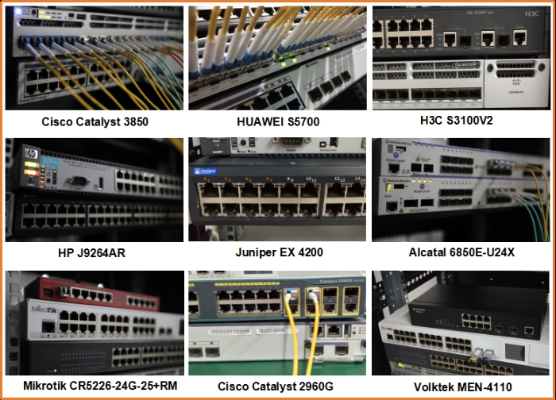

Product Production Process
9

Packaging

10

ETU-Link provides two kinds of packaging, 10pcs/Tray and individual package.
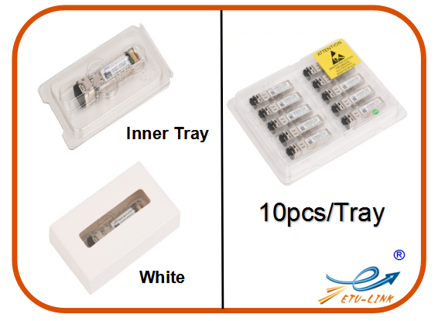

Company: ETU-Link Technology Co., LTD
Address: 4th Floor, C Building, JinBoLong Industrial Park, QingQuan Road, LongHua District,
Shenzhen city, Guangdong Province, China 518109
Tel: +86-755 2328 4603

Addresses and phone number also have been listed at www.etulinktechnology.com.
Please e-mail us at sales@etulinktechnology.com or call us for assistance.
Fiber Optic Transceivers Copyright 2011—2017 etulinktechnology.com All Rights Reserved

Fiber OpticTransceiversCopyright 2011—2017 etulinktechnology.com All Rights Reserved

